# Project Deployment

## Download Node JS

Download Node.js from <https://nodejs.org/en/download/>.

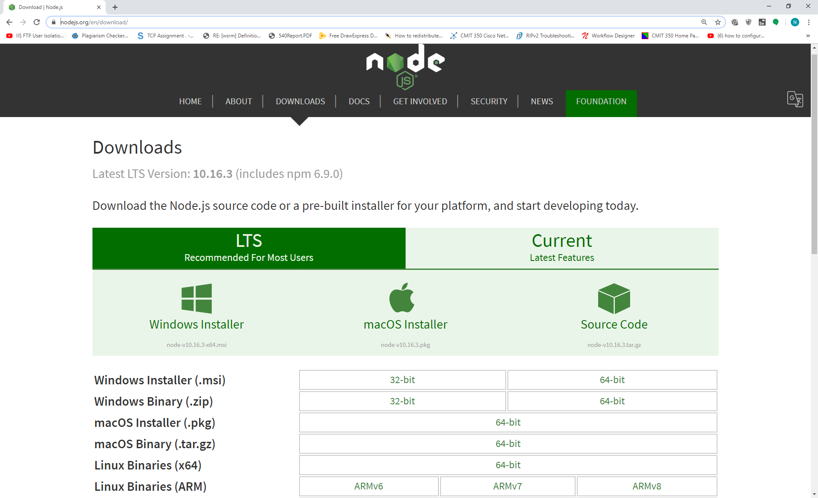

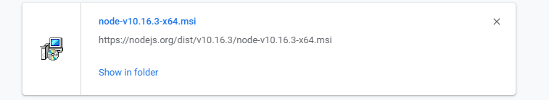

Installation process of Node.JS

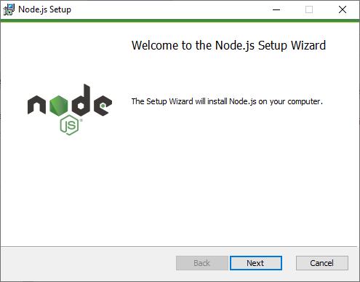

Select the license Agreement and click “Next”.

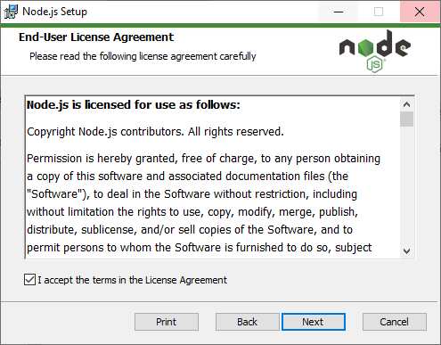

Check all features are enabled in the tree and then click the “Next”

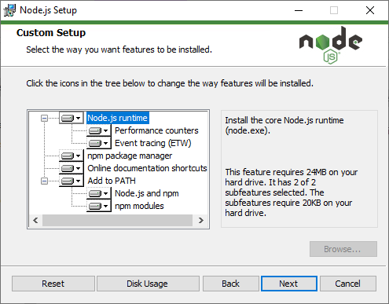

Click “Install” to install the Node.js tool.

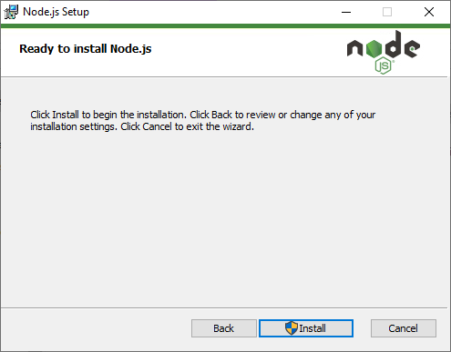

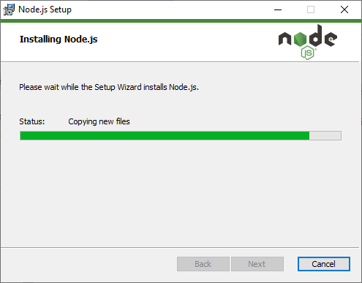

Node. JS Completed the installation process.

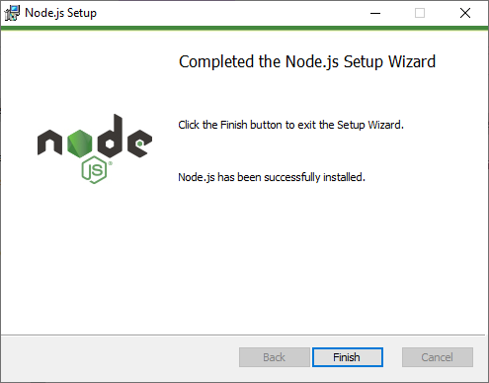

extracted the application code to “C:\TravelGuide-master\”

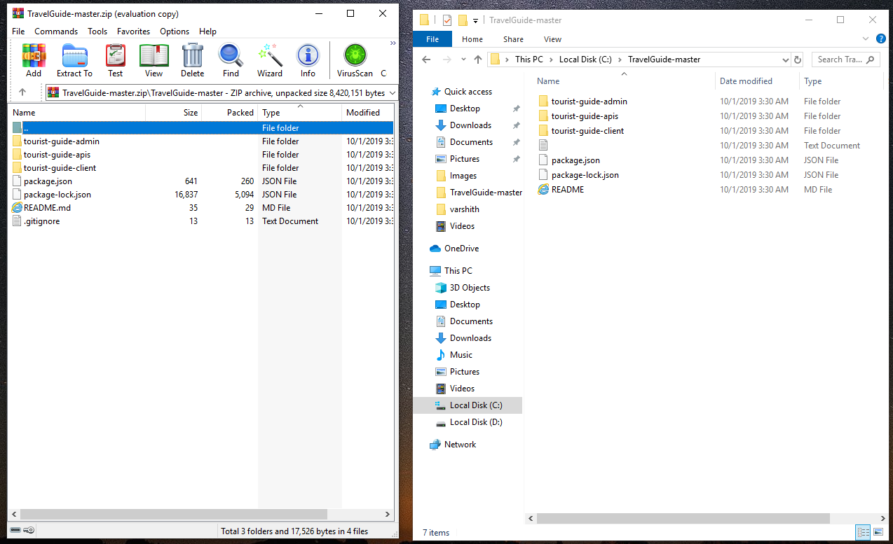

Open Node.JS Command Promt.

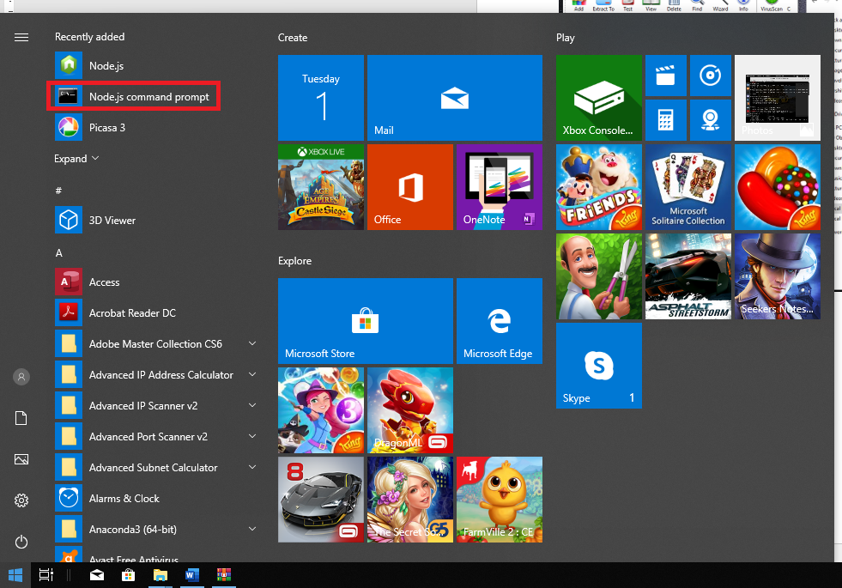

Change cmd path to C:\TravelGuide-master\

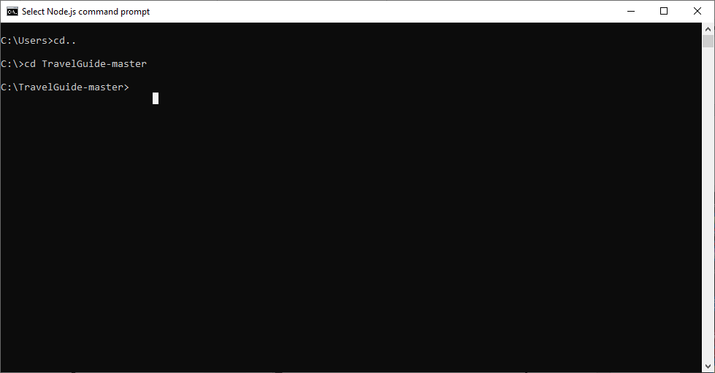

Type the command “npm install” to install all pre-requisite models for the project.

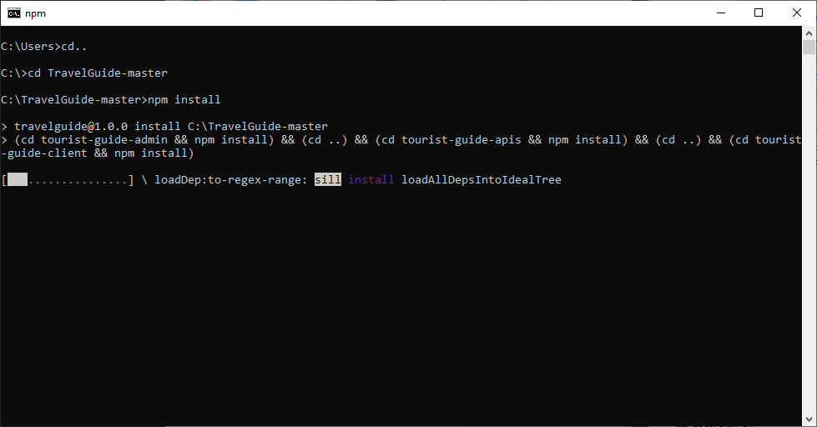

NPM started installing of modules



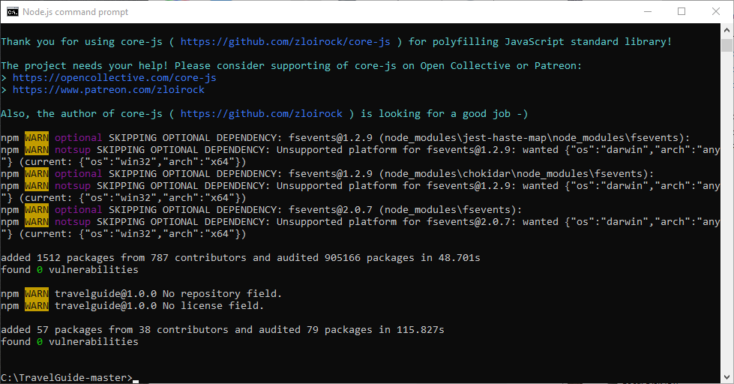

Type the command “Npm start” to start the application.

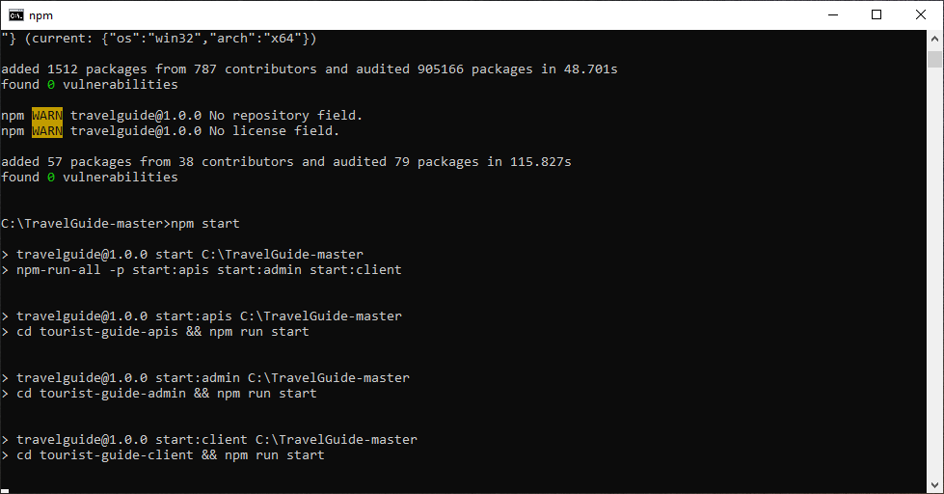

Application started, the below window refers the admin panel

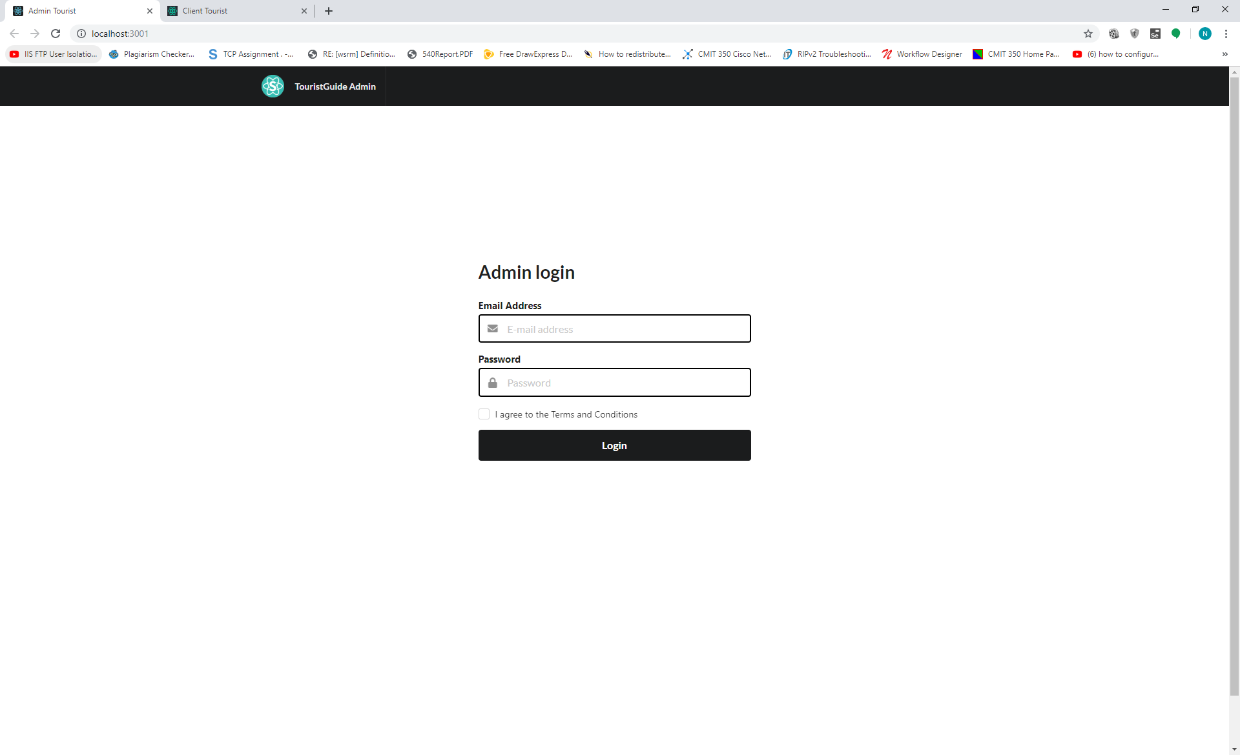

The below window refers as client panel.

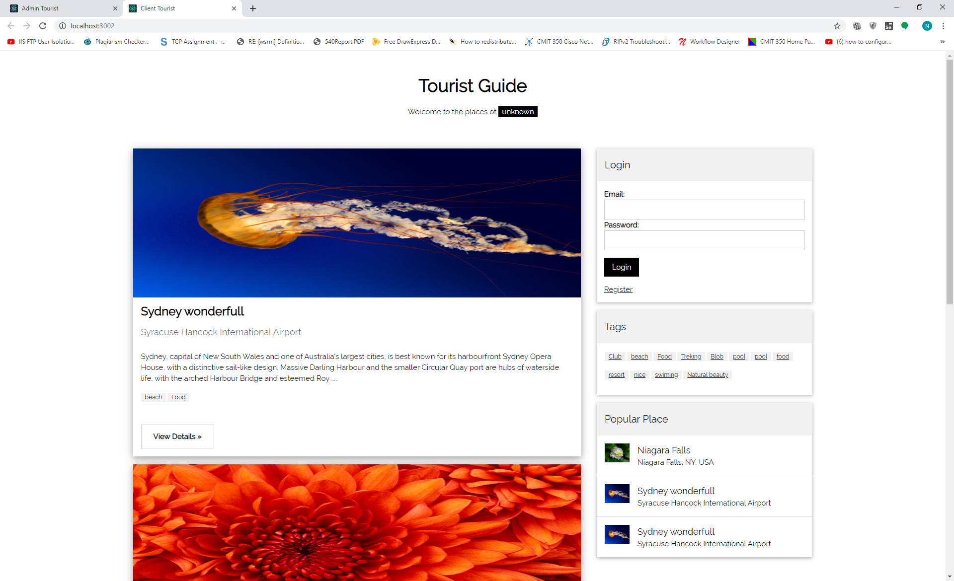

Let’s install visual studio developer coding software. For our meachine.

Download the Software from “<https://code.visualstudio.com/docs/?dv=win>”

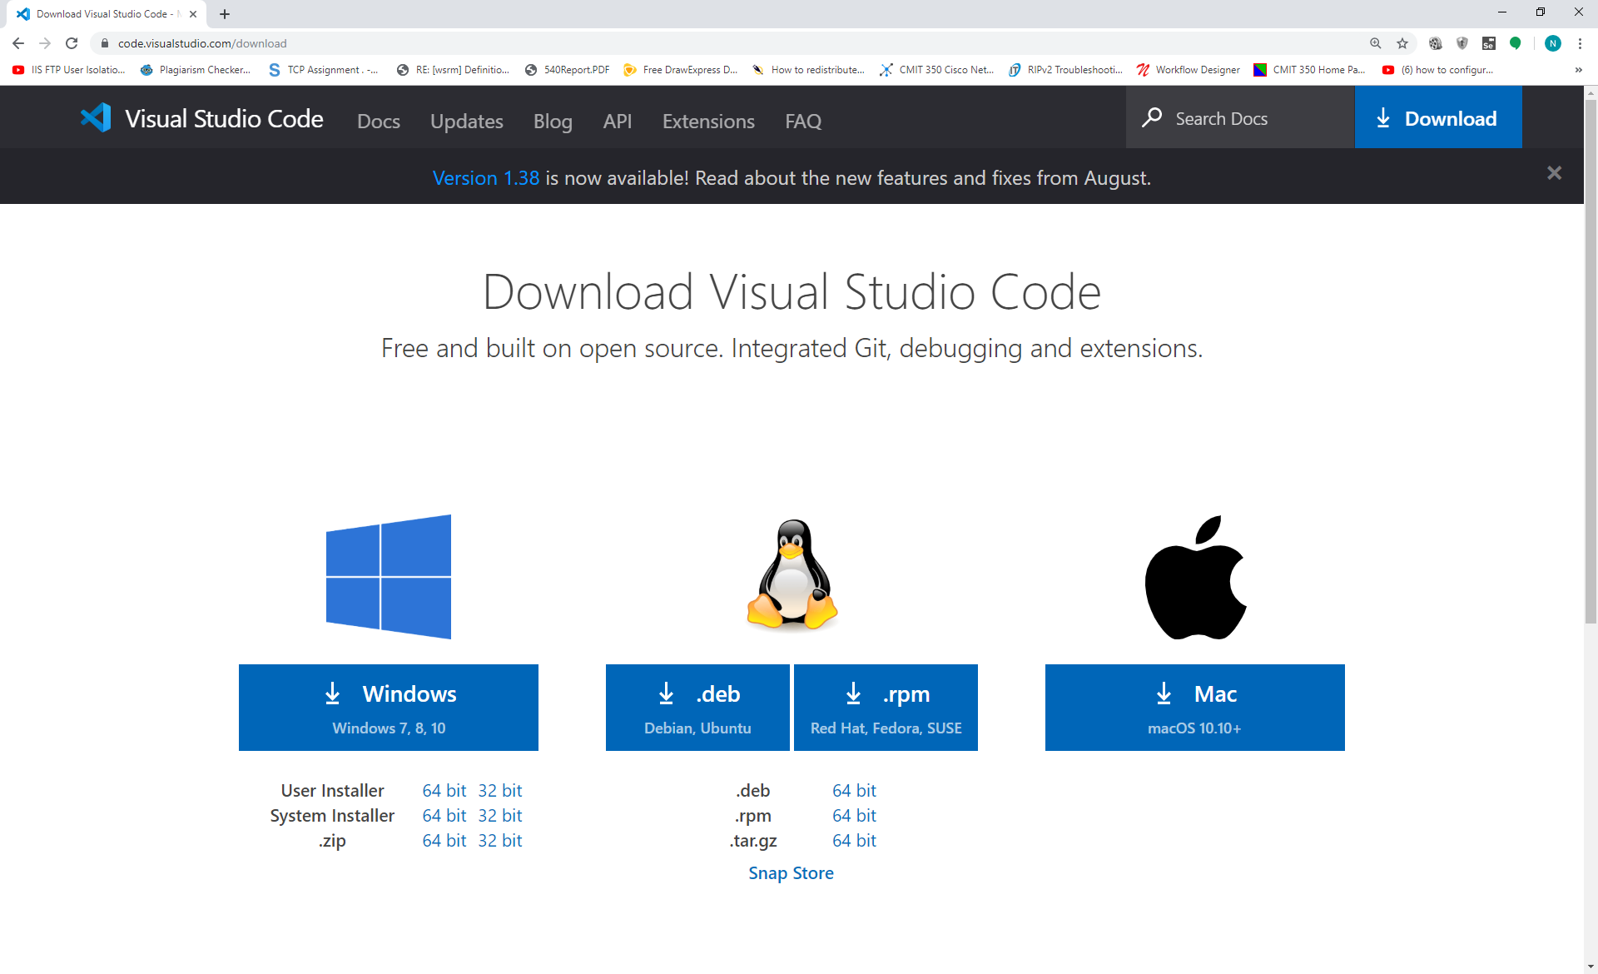

Select the license agreement.

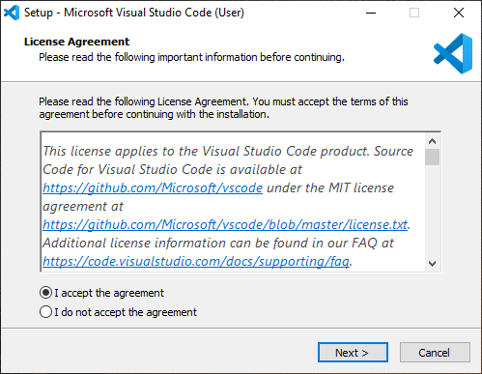

Click next

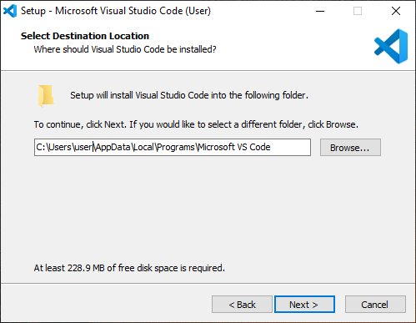

Click Next

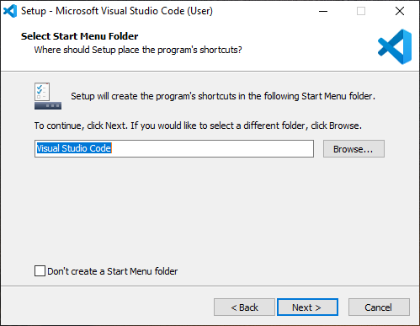

Seelct the “Create a desktop icon” then click Next

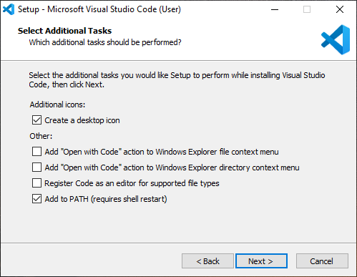

Select Install

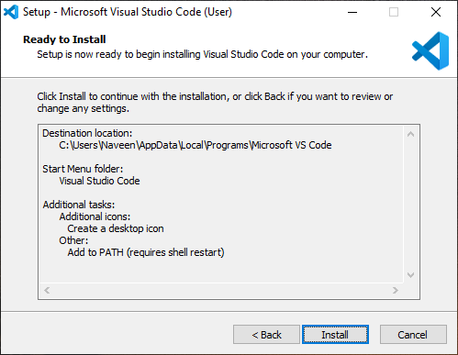

Installation process started.

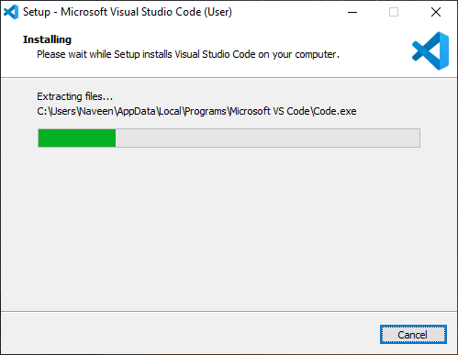

Installation completed. Click finish to start.

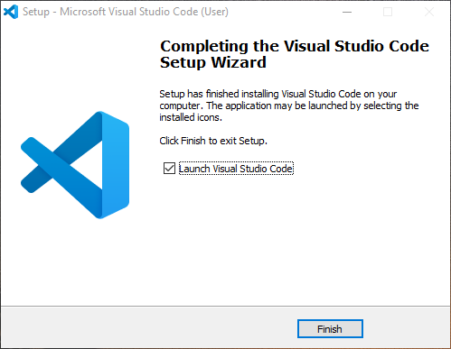

Visual studio code.

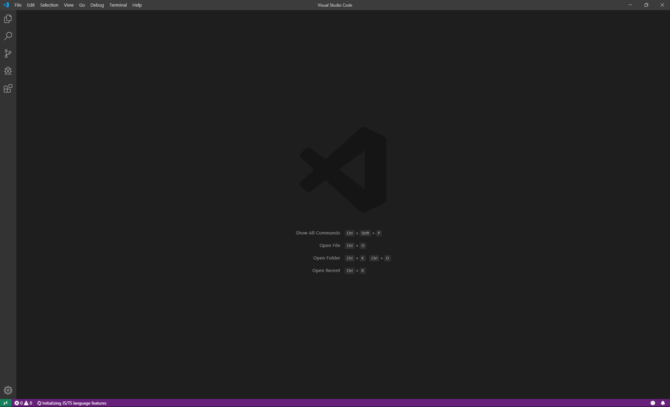

Go to file select “Open Folder”

Select path: “C:\TravelGuide-master”

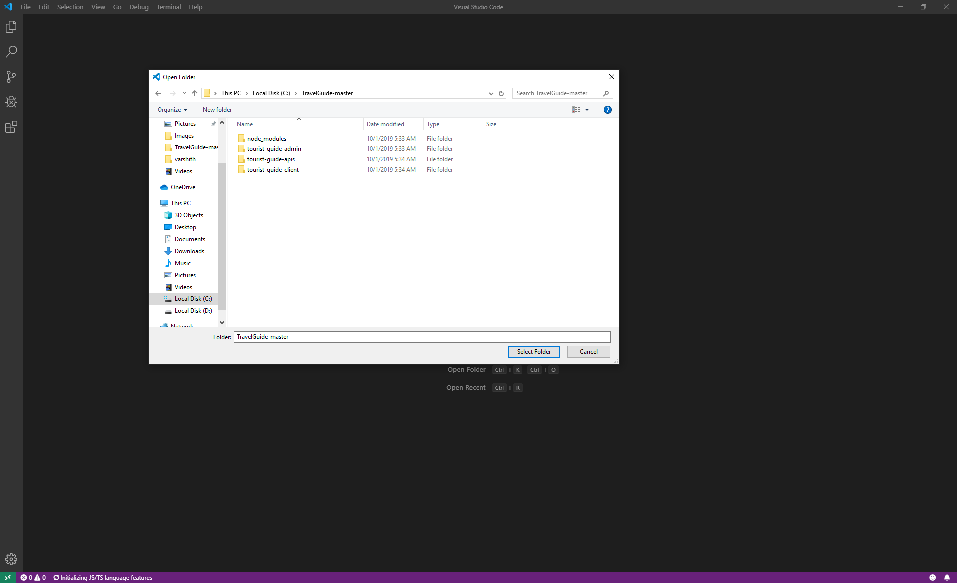

Now we can make changes on the live.

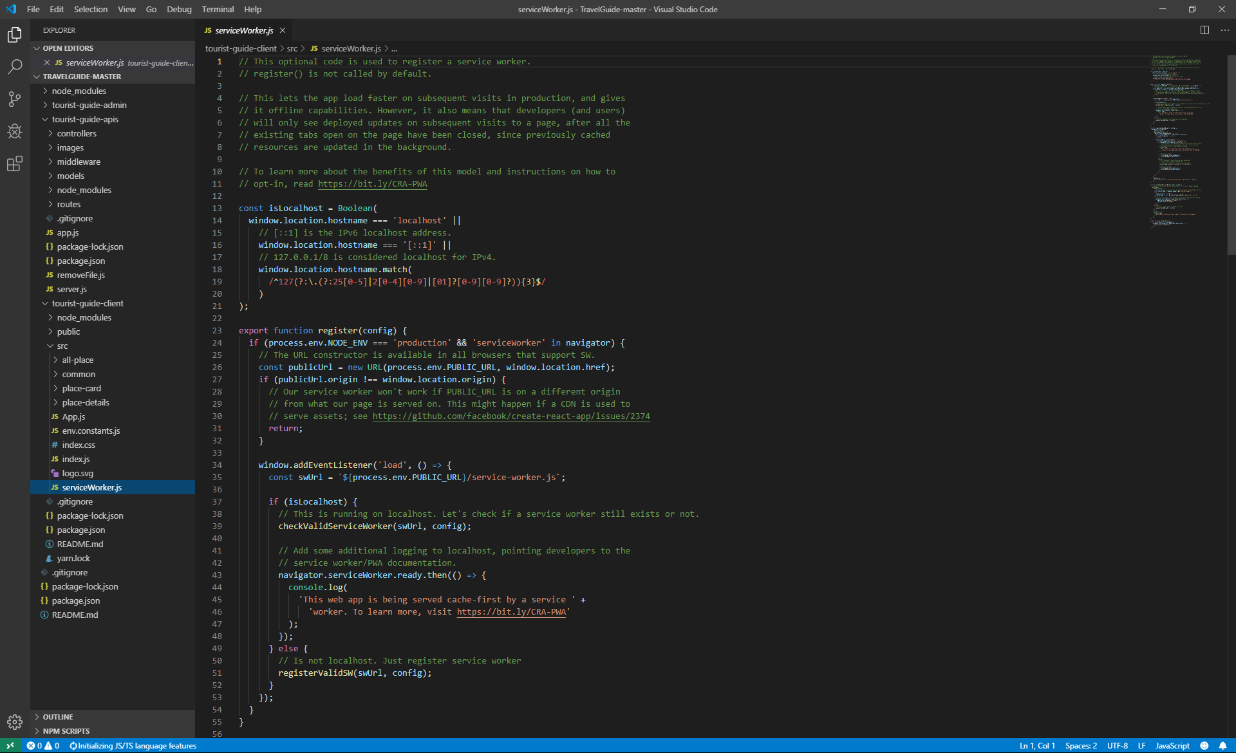

# 4. User Manual.

Admin Login Page.

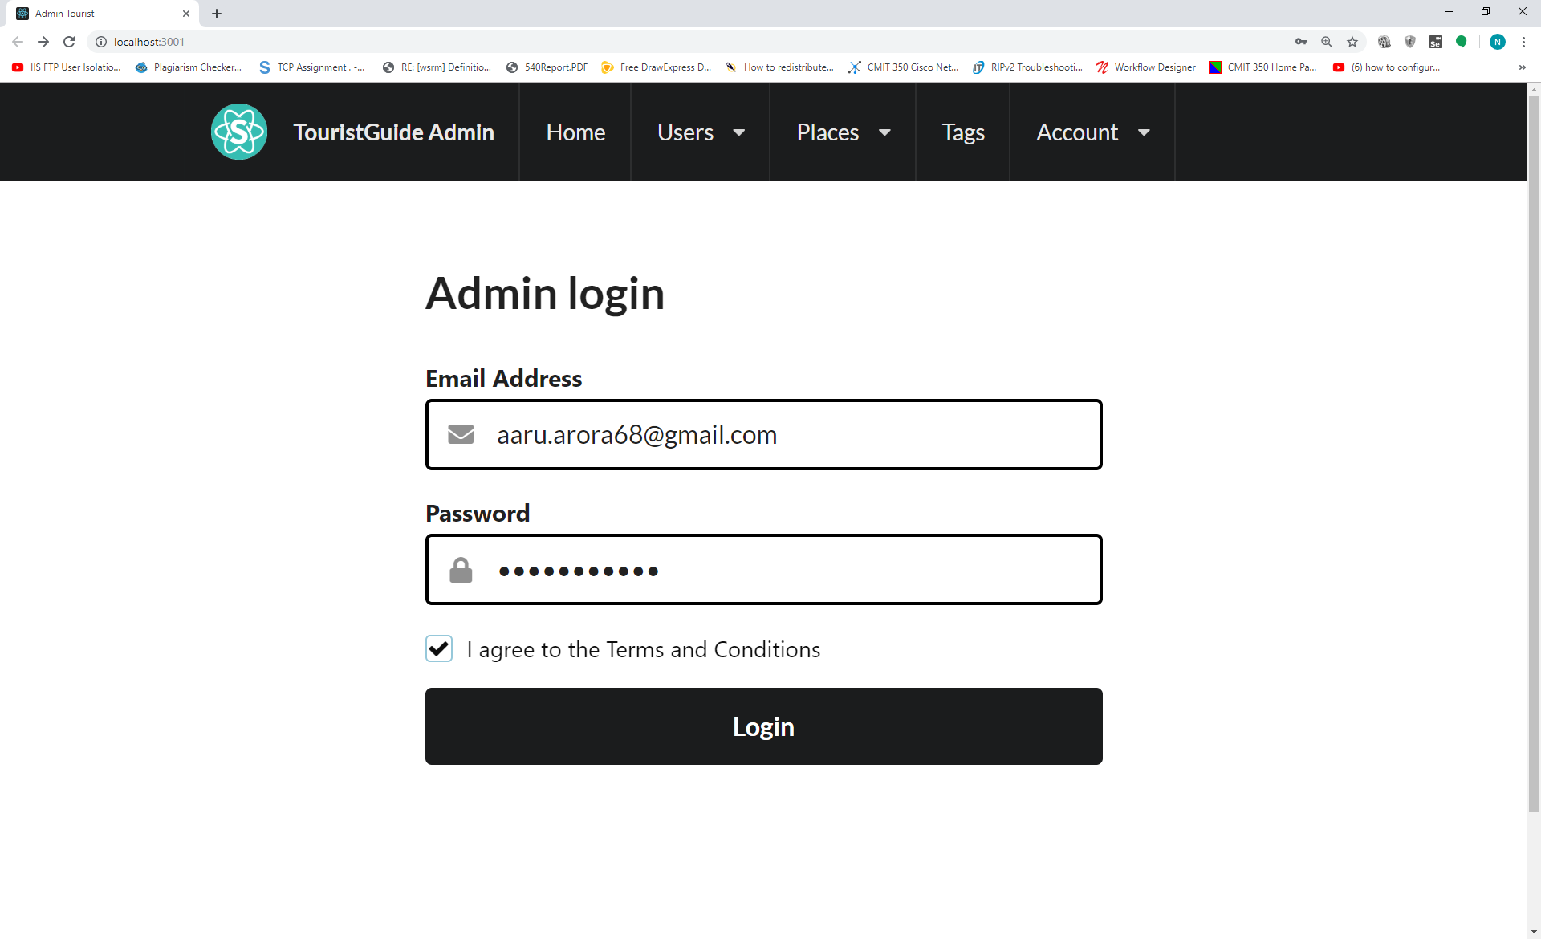

Main Menu



Right Menu

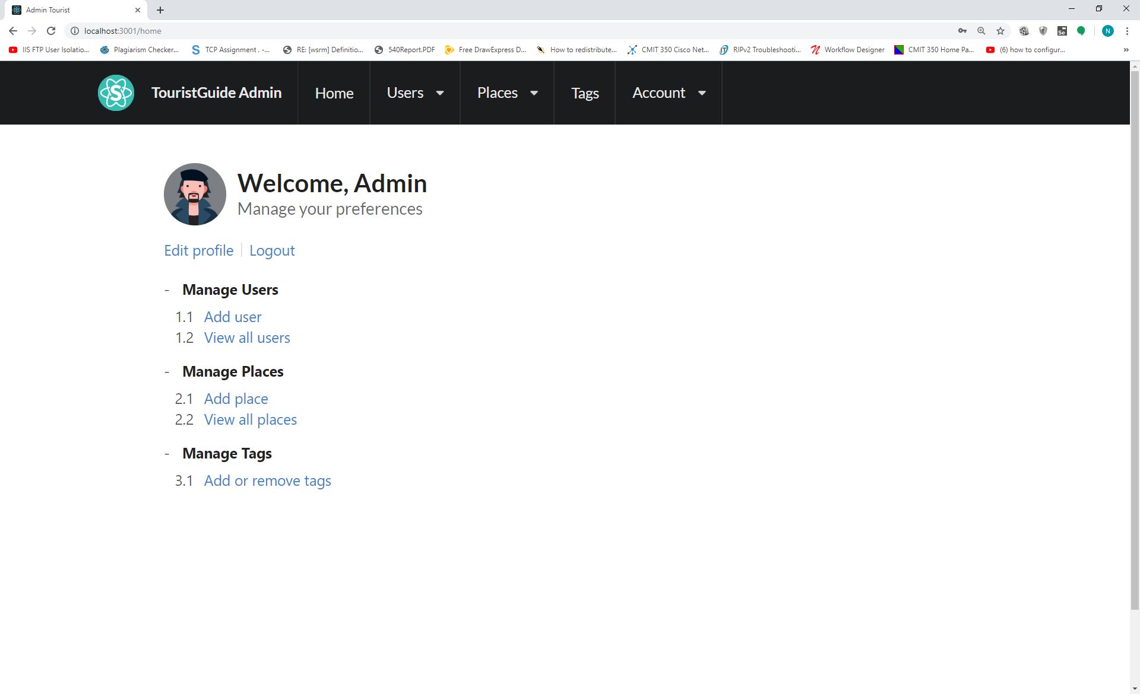

Left Menu

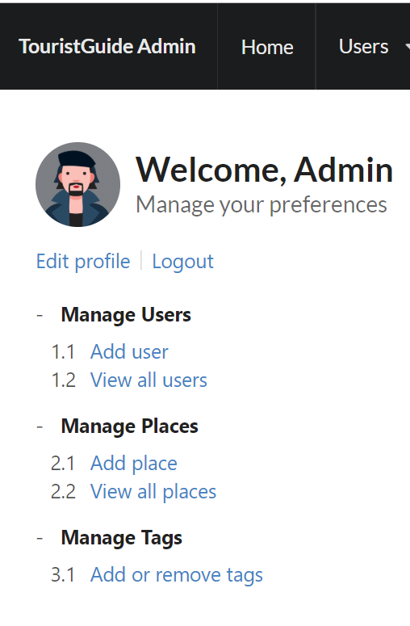

Add User Details

Admin can create new accounts.

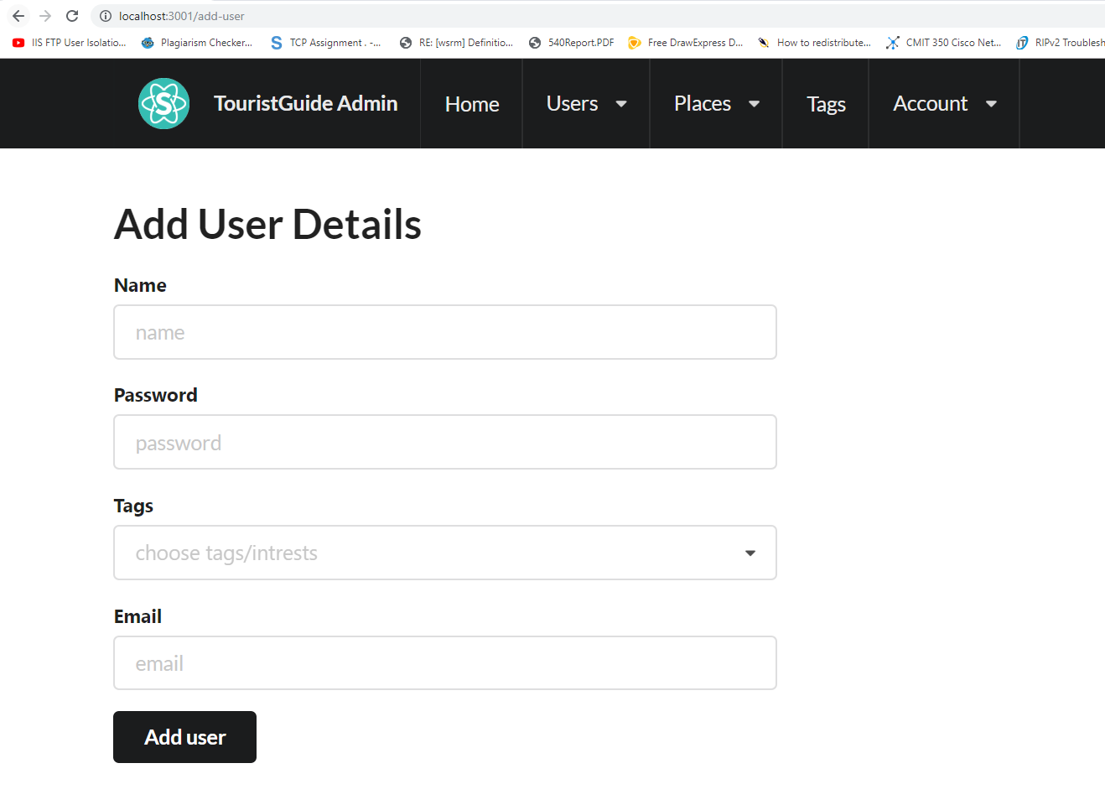

Admin can edit or delete the users from “View all users menu”

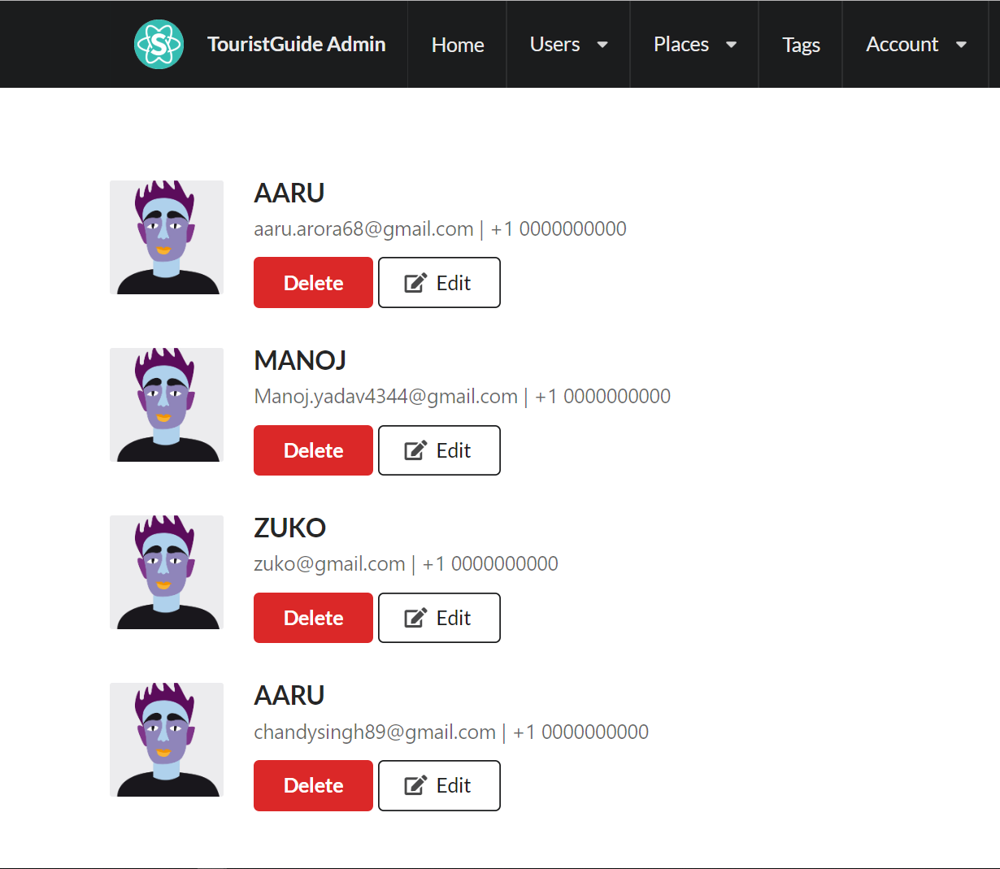

Admin will add the place by Place name, Area, Latitude, Longitude, Tags, File Upload (only 5 images) , address and description.

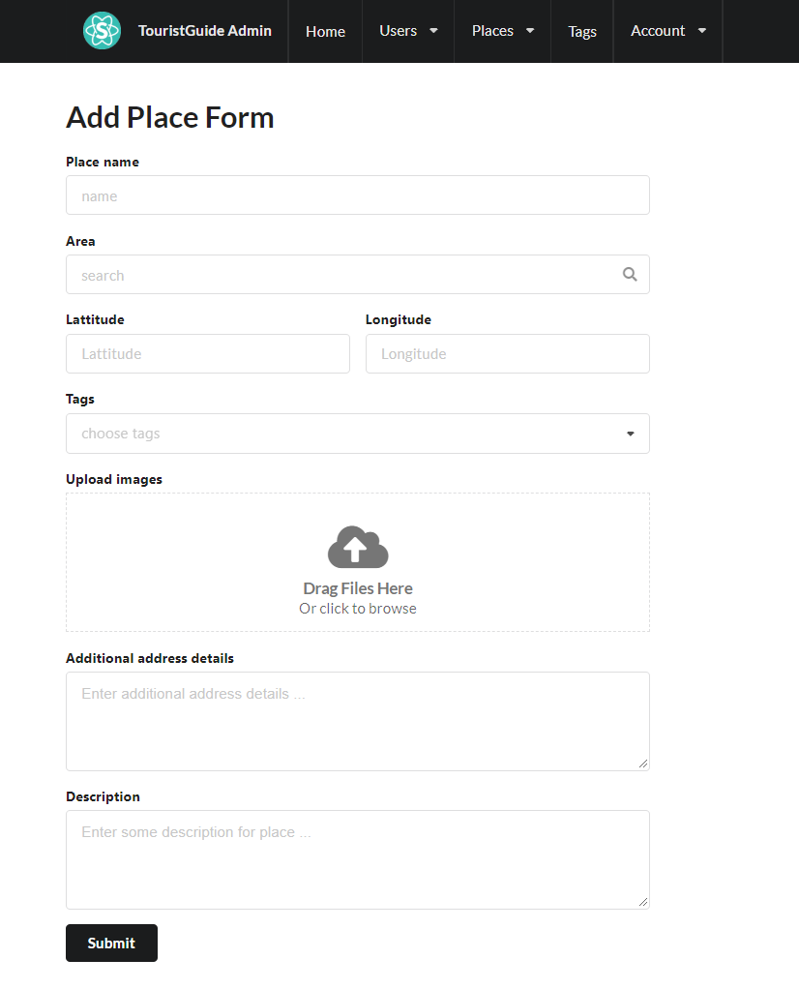

Admin can view and delete the places from “Lists of the pages” menu.

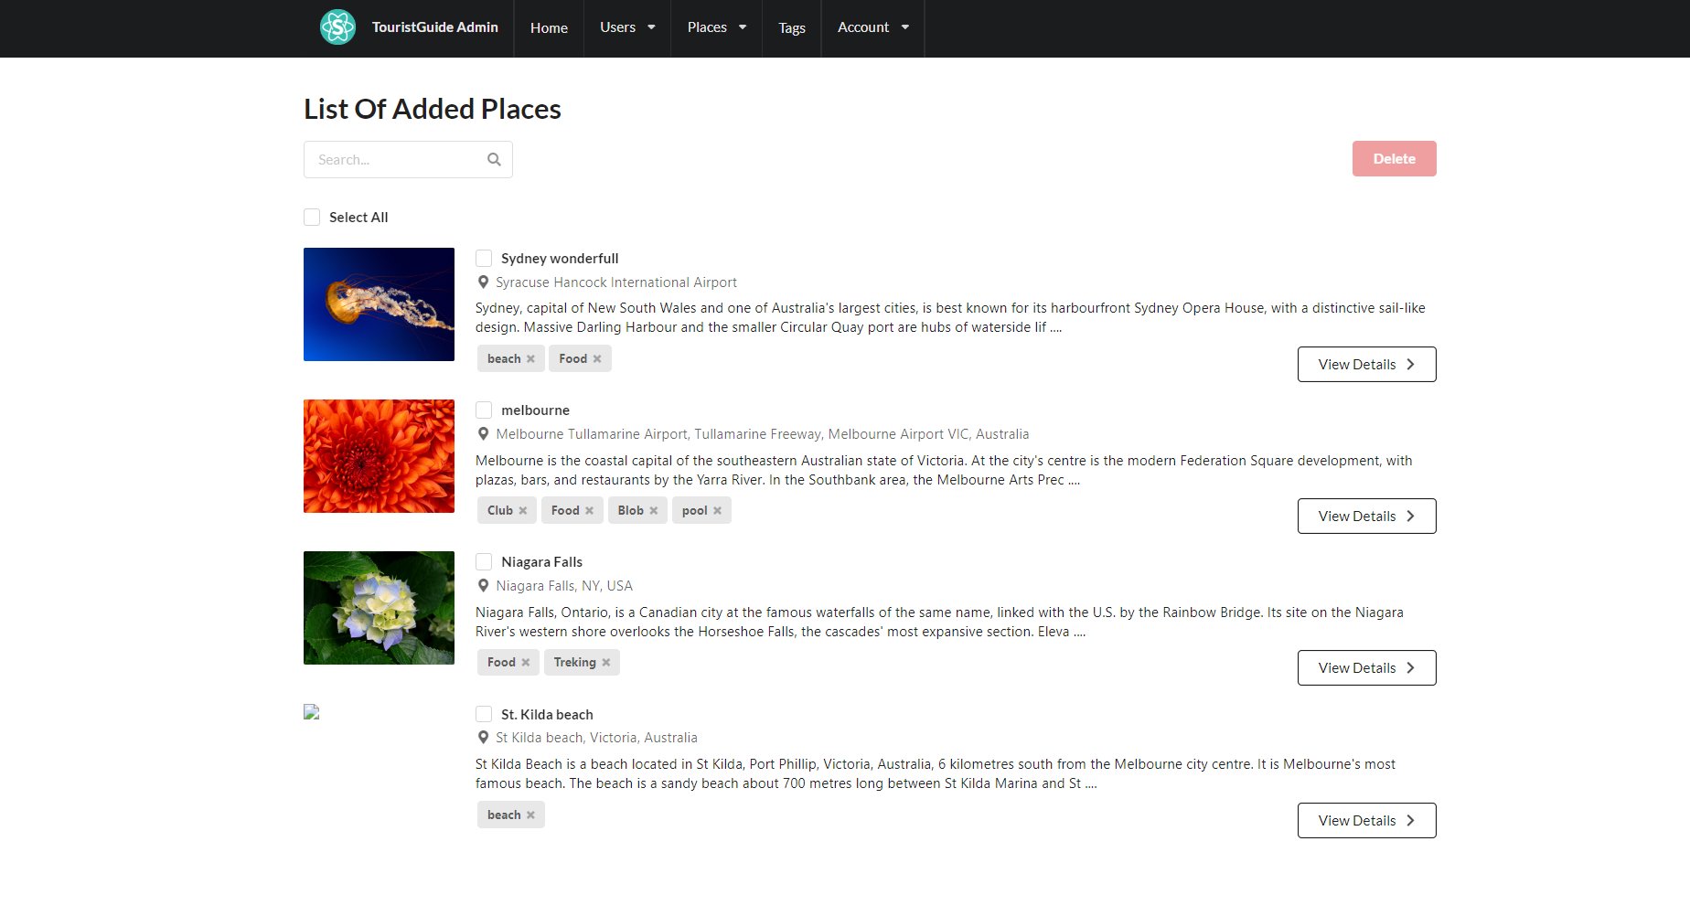

# Add Tags Form

Admin can create N number of tags.

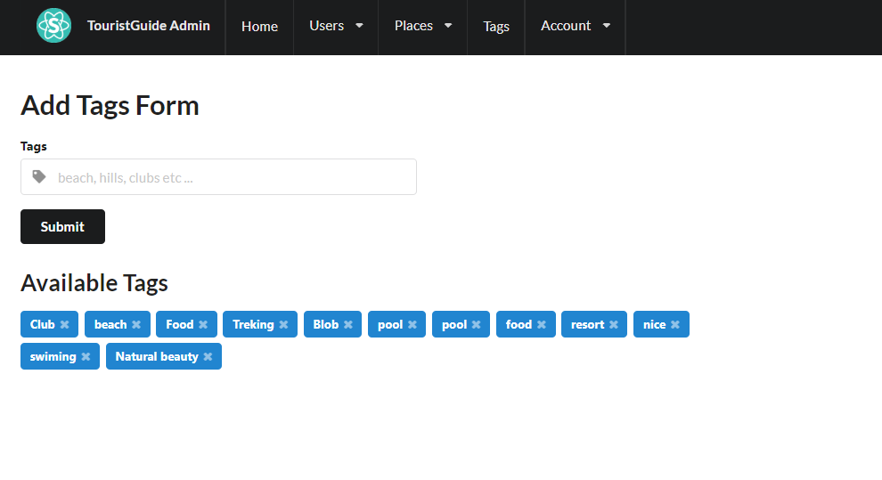

Admin can change his personal details.

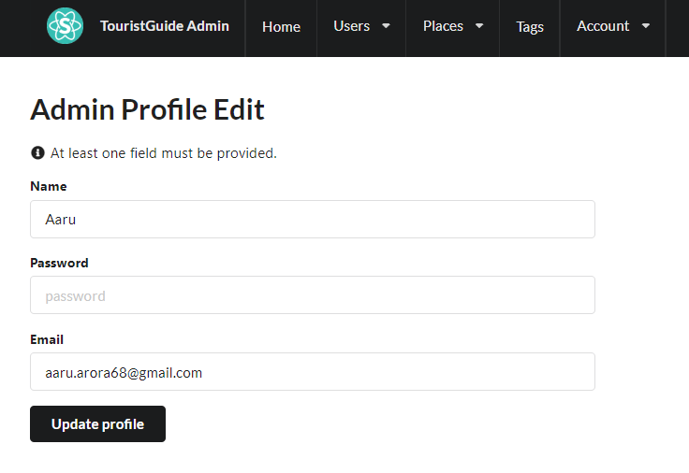

Admin Log-out session.

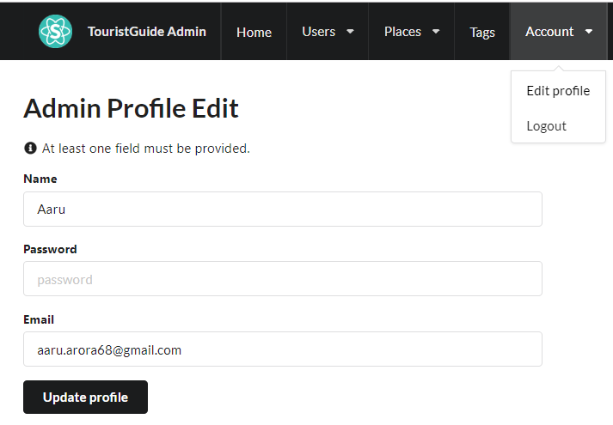

User Portal page.

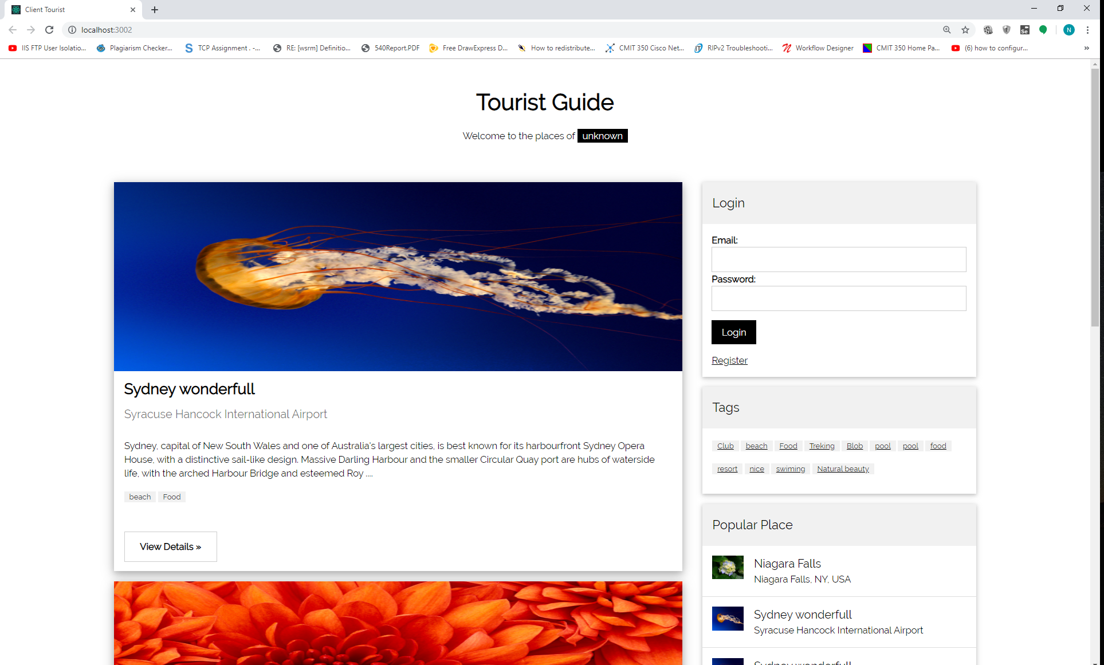

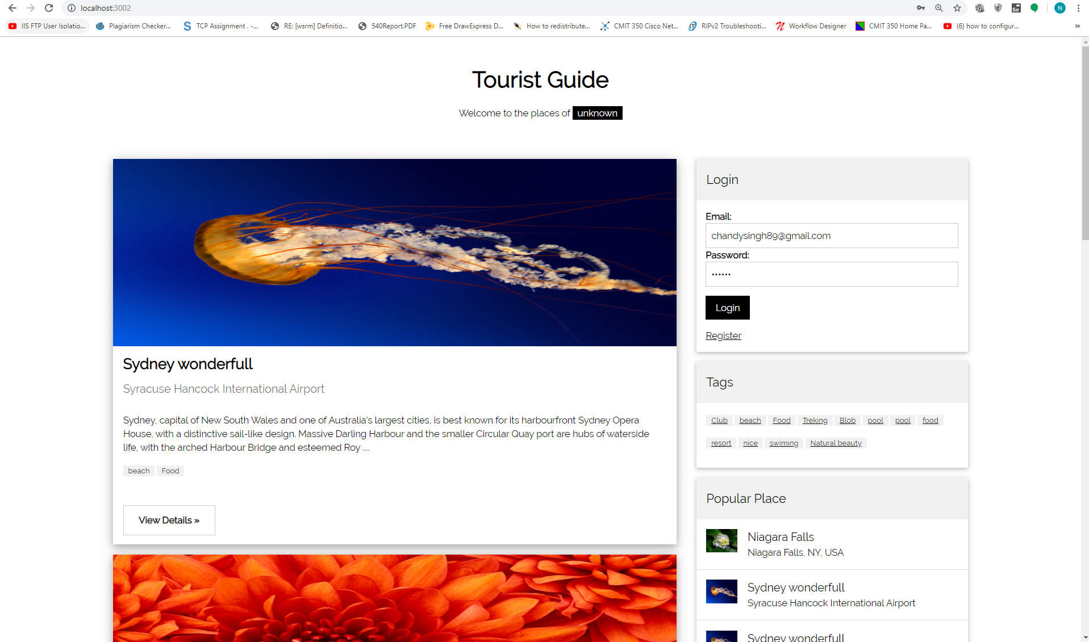

User Dashboard after the login

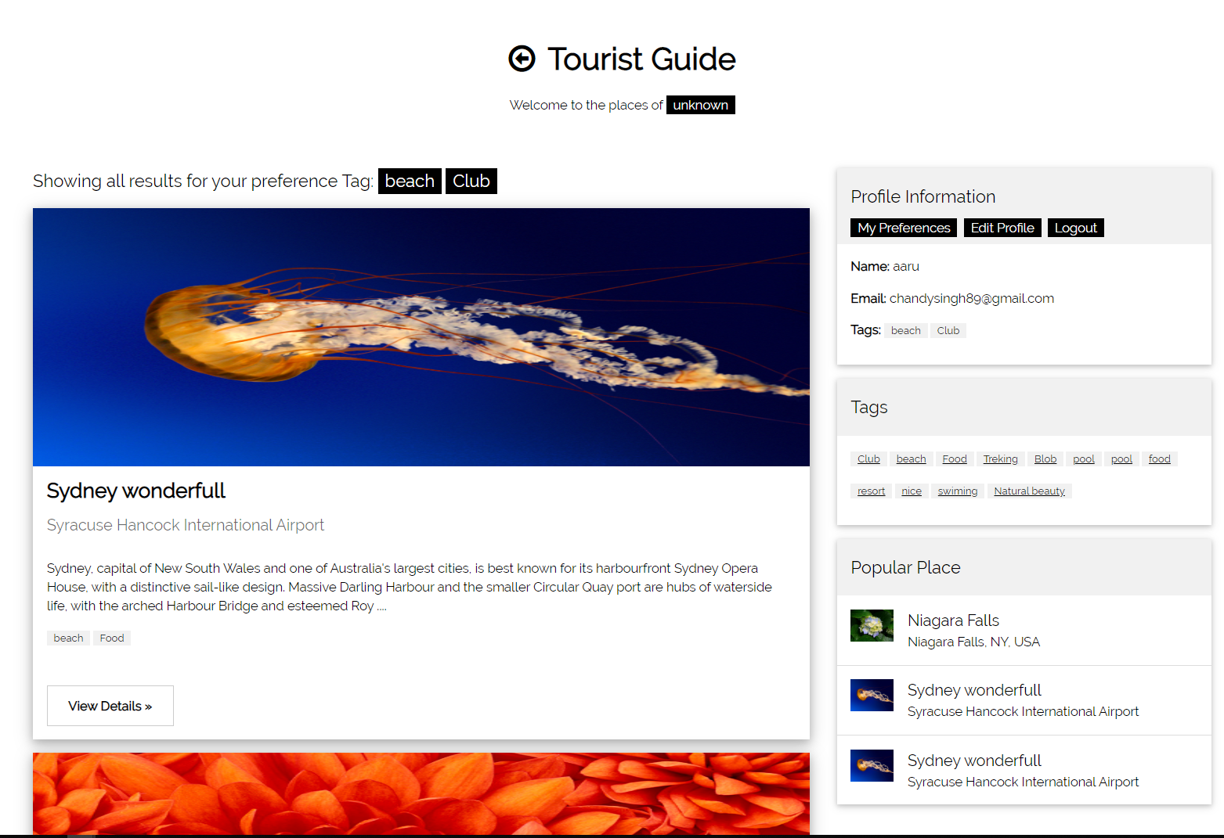

Client users can update their Name, Email ,Tags and password from the client dashboard.

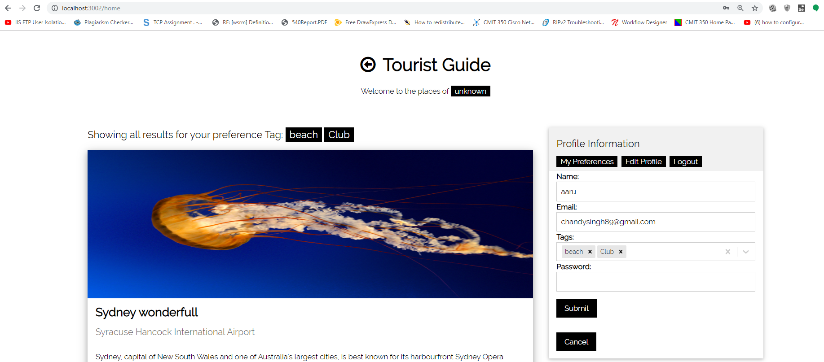

Client users can search the places with the help of the tags.

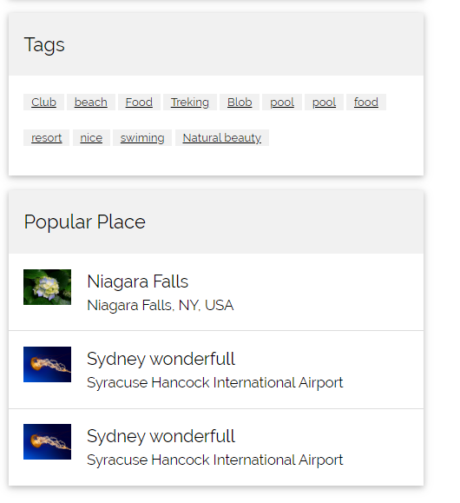

Full details of the place when user logged and validated with his credentials.

